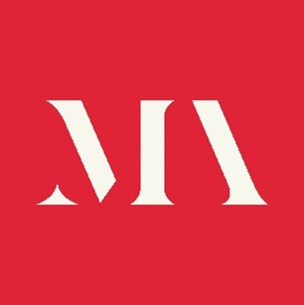

Application Form

Role applied for:

Personal Details

Name

Address

Email address

Contact Telephone

Professional biography
Please enter a brief professional biography below (no more than 100 words).

Personal Statement
Please enter your personal statement below (maximum 200 words) outlining the values, qualities and experience you would bring to the AI and Ethics working group including your understanding and expertise of AI and ethics in museums.

Are you related to any member of the staff or board of the Museums Association?

Declaration
The information I have given in this application form is correct.
Signature Date:

Data privacy
We will treat all personal information in line with current data protection legislation and our data protection policy.

Please return the completed form to Alice Chalk alice@museumsassociation.org

