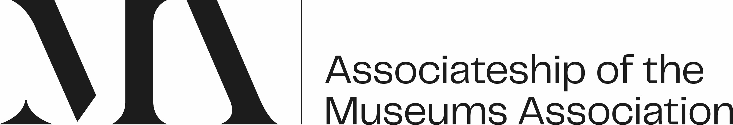

Associateship of Museums Association (AMA):
Mentoring agreement (MA)

Name
Membership number
Mentor Name

At the beginning of your mentoring relationship, it is important to discuss how you will work together, your expectations and basic logistical arrangements.

Mentoring is part of the development framework to support your development, mentoring sessions should take place 4 times a year or as required within agreed contact hours up to 10 hours per year.

We recommend that you both think about the following points, discuss them, and record your agreed way forward and at the first session.

Contact and response time
What is the agreed way for communicating-email, telephone, social media?
What is the agreed response time to the above-a day, a week, a month?
What is the agreed response time to reviewing documents-a week, a month?

Sessions
How long will the sessions last – an hour, an hour and a half or two hours?
How frequently will you ‘meet’ – every other month, every quarter, every six months?
What is the preferred ‘meeting method’ - face to face, telephone, Zoom, Teams, Skype, Facetime etc? (If face to face identify a venue or location.)

Expectations
Please list any other expectations in relation to a respectful and productive mentoring relationship, for example – punctuality, cancellations etc:

Issues
Please outline the approach to be taken if there is a problem within the mentoring relationship, for example lack of responsiveness:

Please co-sign this document and then send the agreed Mentoring agreement to cpd@museumsassociation.org

