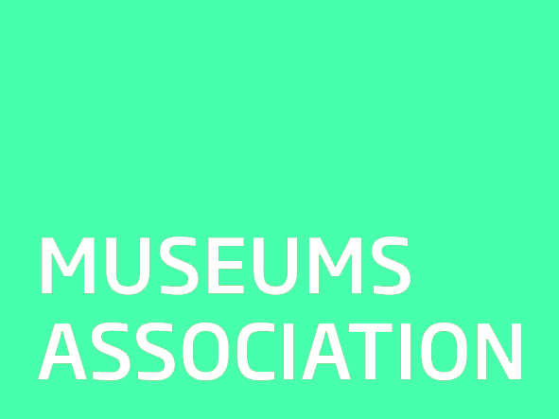

28/11/2018
Museums Association Statement on Repatriation and Restitution
The three key principles of the Code of Ethics for Museums are: public benefit and engagement; collections stewardship; and individual and institutional integrity. All three of these principles should apply in cases of claims for repatriation or restitution from museum collections.
The specific guidance on repatriation urges museums to deal sensitively and promptly with any requests, both within the UK and from abroad.
Factors to be taken into account include the law; current thinking on the subject; the interests of actual and cultural descendants; the strength of claimants’ relationship to the items; the scientific, educational, cultural and historical importance of the items; and the consequences of retention and repatriation for a range of stakeholders.
Claims for repatriation raise important question about public benefit and museums’ relationship with communities both in the UK and abroad.
In particularly the views of source communities should be taken into account and museums should strive to build lasting and meaningful relationships with these communities.
We would encourage museums to develop constructive relationships with representatives of people who contributed to collections and take proactive steps to inform them of the presence of items relevant to them in the museum’s collections.

